
My Redeemer Christ Can Deliver (M.R.C.C.D.)

Mark, Roxane, Crystal, Cassandra, Daniel Davis
650 Linwood Dr., El Paso ,TX 79928
US: 1-915-443-8366 / MX: 1-763-269-6946

Financial gifts please send to:
My Redeemer Christ Can Deliver (M.R.C.C.D.)
Attn: Paul Davis
2631 Wood Crt. S.W., Olympia, WA 98512

Direct deposit: Well’s Fargo Acct. # 6473041108 / Routing # 112000066

15 of March 2018

To God’s Ambassadors:

Our hearts cannot express enough to each and everyone that have been standing with us so fervently for so many years! As we have and mostly likely each one of you that have desired to live your life according to His plans – forsaken all else - have been tested or tried as stated in 1 Peter 1:7, That the trial of your faith, being much more precious than of gold that perisheth, though it be tried with fire, might be found unto praise and honour and glory at the appearing of Jesus Christ.

Looking back now over the years we have seen many miracles that pertain to our lives personally and would like to share just a few of those that really stand out in our minds:
- We completed 25 years of marriage. Being with your mate 24/7 can be taxing at times but we would not have done anything different. Thank you Jesus for this miracle!
- God blessing us with children late into our lives: Roxane was 37 when Crystal was born, 38 for Cassandra, and 39 for Daniel.
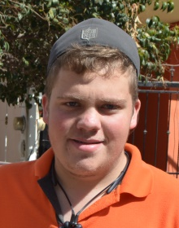
Thank you Jesus for this miracle!
- Our second daughter Cassandra – to the left – when she was four, fell into a two foot burning fire pit of which she lost all the skin off her left arm from the wrist to her elbow and all the skin on the palm of her right hand. Praise God, He protected her face – she didn’t need skin grafts – and has very little scars compared to what could have happen. Thank you Jesus for this miracle!
- Our boy Daniel, when he was about five, fell off a 7 foot stair case that was being built, landed on his chest and his head missed the edge of a metal wheel barrow by inches! Thank you Jesus for this miracle!
- When our van, that had 11 people almost rolled off a bridge about 5 yrs. ago. Thank you Jesus for this miracle!
- Roxane was able to kiss her daddy goodbye before he died. Drove from San Juanito to El Paso, then took a plane to Minnesota, and arrived just hours before he passed away. Thank you Jesus for this miracle!
- Our three children love God and desire to trust Him fully with their own lives. Thank you Jesus for this miracle!
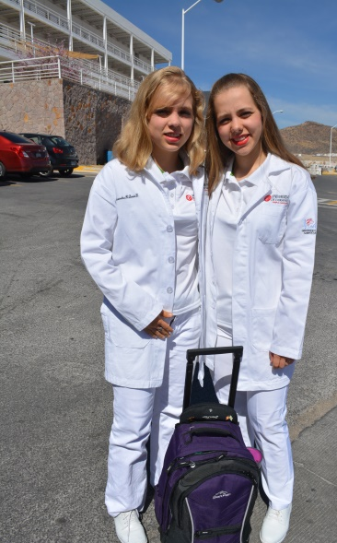
- We have a beautiful home in El Paso that is totally paid for! After 20 plus years living in a 30 feet trailer or staying with special friends, the Lord made it possible for us to purchase! Thank you Jesus for this miracle!
- Crystal after passing the examines in the US, received her GED, registered in a medical school in Cuauhtémoc, only to find out that the GED was no longer valid in MX as of two years prior. With much investigation and guidance by the Holy Spirit, we were able to register her, along with Cassandra, in a US home-school program that gave them an official document that MX accepted. Thank you Jesus for this miracle! In the middle of this disappointment, we asked Crystal why she just doesn’t study in the states since we have a home in El Paso, and with tears in her eyes she said: “Why do I want to do that? I would like to receive my medical career from MX, where I can learn the Spanish medical terms and eventually open up my own clinics in the Sierras. I believe that is what God is calling me.” After a response such as that, we returned back to our investigation.
- Our children’s desire to study at a Mexican university. Crystal and Cassandra are seen here starting their 2nd semester of medical school. Thank you Jesus for this miracle! First semester they entered with about 200 students, and has already dropped to about 80 students. Our girls need your prayers: That they will remain faithful to Him, especially when their faith is being challenged and tested, and that God will give them the understanding and wisdom in their studies; considering everything is in Spanish. Daniel as of right now is planning to enter into the same school in 2019 but in the nursing program.
- We have traveled thousands and thousands of miles between seeing family in Washington and Minnesota, and all the trips made back and forth from El Paso into Mexico. We have had some very close calls – feet away – but God kept us safe! Thank you Jesus for this miracle!
- We all are Mexican nationals. Cassandra and Daniel by birth, Mark, Roxane, and Crystal after about 12 years of paper work. Thank you Jesus for this miracle!
- The majority of our supporters have been standing with us for over 20 years! We are so blessed to have the prayers and financial support behind us. Thank you Jesus for this miracle!
- Over all our health is great! We have been trying very hard to watch our weight and eat right because we, such as your selves, desire to see our children blossom more and more into His image and prayerfully be able to see our grandchildren follow into His footsteps. Thank you Jesus for this miracle!

These are just a very few of the innumerable miracles of how God has miraculously worked in our own lives personally over the many years. We know that each and everyone of you that have totally trusted God with your lives can also put together a never ending list of how He has touched and intervened in your life personally!

As far as the ministry goes – the church in San Juanito has had a number of returning families, and new souls were added to the Book of Life! Thank you Jesus for this miracle! Roxane lives out in Chihuahua with the girls and at times she has been wanting to start up English classes to help with the extra expenses, but with the demands of the ministry that requires her attention such as church related computer work, preparing children’s ministry, all the bookwork / paperwork that is involved – personally and ministry wise, keeping Daniel on top of his school, making ministry type phone calls, keeping the Chihuahua rental house in order so the girls can devote as much as they are able into their studies, and last but not least keeping the family together as much as possible even while we are apart. Mark keeps so busy since he is now overseeing the ministry with the help of our assistant pastors. Not to mention working on the parsonage home, which had to be put on hold for a few months but prayerfully after Easter we will once again restart the project. Between ministering to the people that come calling upon him, visiting others at their homes, doing a weekly home bible study, visiting the people at the hospital or those that are sick, and doing maintenance on vehicles and buildings, his days are pretty filled and busy!

We close now with this verse in Ephesians 1:16-17, Cease not to give thanks for you, making mention of you in my (our) prayers; that the God of our Lord Jesus Christ, the Father of Glory, may give unto you the spirit of wisdom ad revelation in the knowledge of him.

With all God’s Blessings,

Mark, Roxane, Crystal, Cassandra, and Daniel Davis

