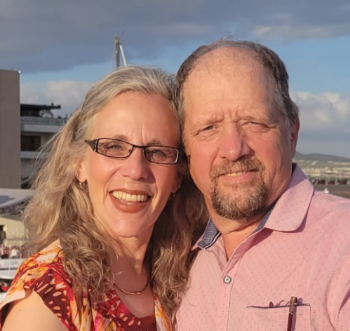

My Redeemer Christ Can Deliver (M.R.C.C.D.)

Mark, Roxane, Crystal, Cassandra, Daniel Davis
17018 Darrington Rd.
Horizon City, TX 79928

Contact information:
Email: yeposo@gmail.com
Prior Updates: mrccd.wordpress.com
US cell phone: 915-279-4424

June 24, 2025
Greetings to all of you who have supported us throughout our many years of service in Mexico through your prayers and financial support. Here is just a brief summary of what is going on within the ministry and within our family. Without repeating details from previous updates, as of January we have been holding four Bible studies per week:
- Sunday at 4:00 p.m. – Old Testament Study: We recently finished the book of Genesis and, as of two weeks ago, started the book of Exodus.
- Monday at 8:00 a.m. – Proverbs Study: Each Monday, we study one chapter, going verse by verse.
- Wednesday at 7:00 p.m. – Revelation Study: We just completed chapter 19.
- Friday at 8:00 a.m. – New Testament Study: We’ve already reviewed the books of Matthew, Mark, Luke, and John, and about two weeks ago we began the study on the book of Acts.

During Easter, we did a deep study on the Crucifixion and Resurrection of our Lord Jesus Christ. Since I have primarily worked with children for the past 15 years, it has been a delight to dive deeply into the scriptures and discover so many “hidden nuggets.” It’s amazing how much more one can learn when taking the time to dig into God’s Word and see how the Old and New Testaments are so beautifully interwoven.
For the Sunday and Saturday studies, we usually have around 15 to 20 in attendance. For the morning studies, due to most people working, we generally have around five.
Since January, we no longer hold Sunday morning services. We have seen a major decline in the desire to follow God and to be committed to Him. With so many “Christian” churches in our area, we have felt God leading us to focus on deep Bible studies. Our goal is to help those attending grow deeply in their faith and be so grounded in the Word that they will never be shaken.
Additionally, we are gathering materials to prayerfully start a resource center to support churches in our area and surrounding communities. Our hope is to provide pastors with resources to better meet the needs of their congregations. This includes Bibles, Sunday school supplies (projects, crayons, glue, scissors, etc.), and making our in-depth Bible studies available to them.
In our previous updates, we mentioned our desire to start an alcohol and drug rehab center. However, for one reason or another, we have not yet been able to begin this project. God knows that our heart is to be available to fulfill His purpose through us, so we are simply waiting on Him to prepare the way and bring the right people alongside us. We understand that once the center is up and running, we will need individuals who can provide these services and be available to manage the center during our absence—whether due to travel or other responsibilities.
Family Update:
All three of our children recently received their professional titles. Crystal and Cassandra are now general doctors, and Daniel is a Registered Nurse.
- Crystal, as many of you know, married Carlos in October—a wonderful man who loves and fears God. They are doing well as they adjust to married life in Chihuahua, Mexico. We are blessed to have Carlos as part of our family, and we’re proud of Crystal for becoming a woman who both fears and loves the Lord. It’s exciting to see how God is—and will continue—using them in ministry.

Crystal is working at a clinic, providing consultations, prescribing medications, and referring patients to specialists when needed. She has had many opportunities to share her faith with those she comes in contact with—her boss, her coworkers, and the many patients who specifically request to be seen by her.

Carlos works in the finance department at GCC, a large cement company with over 100 plants in the U.S. and many more in northern Mexico. His role often requires him to travel to various cement plants in Texas, Colorado, and Montana. When he's not working, he devotes much of his time to the worship team at their church, playing the keyboard and guitar.

- Cassandra moved to Ohio in February to pursue a relationship with a young man she met about 10 years ago. While there, she’s working at a Honda plant—not something she enjoys since she’s a doctor, but the pay is good and she is desiring to build up her savings. Though it’s hard to have her so far away, we are trusting that God will lead and guide her.

- Daniel, after earning his RN title, spent three months working in Alaska. While the pay was great, he found it difficult to adjust to the climate and the unusual daylight patterns. He is currently in the process of looking into the requirements to work as an RN in the U.S. In the meantime, he’s doing Uber Eats deliveries and working on establishing his own mechanic business.

We’re so proud of what Daniel has accomplished—especially considering the many struggles he had to overcome while at university. As homeschool moms, we understand our children’s potentials, their weaknesses, and their strengths. That said, I’ll be the first to admit that I had some doubts about whether Daniel would be able to complete this five-year degree.

Crystal and Cassandra also had their share of hurdles to overcome, but Daniel truly surprised us all—and probably his university professors as well! He faced tough challenges at the beginning, but with God’s help, he overcame them all.

He’s gone from wearing greasy mechanic clothes to wearing a white nurse’s uniform to care for patients. I’m sure God finds humor in that!

Living in a foreign country has come with many, many challenges—but now, being on the other side of the hurdles, I am so grateful to God for giving us the privilege of serving Him among the people in this country!

Prayer Requests:
- That God would continue to help us prepare these four weekly studies, that attendance would increase, and that those who attend would grow in the knowledge of His Word, walk firmer in their faith, and be abundantly blessed!
- That God will guide us as we open the resource center to support the needs of the churches.
- That God will lead Crystal and Carlos as they seek His will for their lives.
- That God will guide Cassandra and Daniel as they step into their independence and strive to follow Him at all cost.
- That God will provide us with the much needed support to be able to start the alcohol and drug rehab center.

We are grateful to you for having taking the time to participate in our lives by reading this letter. Please feel free to contact us with any questions that you might have.

Thank you for allowing us to be your hands and feet to the people
here in the Sierras!

Mark, Roxane, Carlos, Crystal, Cassandra, and Daniel

